https://docs.microsoft.com/en-us/aspnet/mvc/overview/getting-started/introduction/getting-started

Getting Started with ASP.NET MVC 5

05/28/2015 3 minutes to read Contributors

* [Rick Anderson](https://github.com/Rick-Anderson)

* [Isaac Levin](https://github.com/isaac2004)

* [Andy Pasic](https://github.com/v-anpasi)

* [Tom Dykstra](https://github.com/tdykstra)

by [Rick Anderson](https://github.com/Rick-Anderson)

An updated version of this tutorial is available [here](https://docs.microsoft.com/en-us/aspnet/core/tutorials/first-mvc-app/start-mvc) using the latest version of [Visual Studio.](https://www.visualstudio.com/) The new tutorial uses [ASP.NET Core MVC](https://docs.microsoft.com/en-us/aspnet/core/mvc/), which provides **many** improvements over this tutorial.

This tutorial teaches ASP.NET Core MVC with controllers and views. Razor Pages is a new alternative in ASP.NET Core 2.0, a page-based programming model that makes building web UI easier and more productive. We recommend you try the [Razor Pages](https://docs.microsoft.com/aspnet/core/mvc/razor-pages) tutorial before the MVC version. The Razor Pages tutorial:

* Is easier to follow.
* Covers more features.
* Is the preferred approach for new application development.

This tutorial will teach you the basics of building an ASP.NET MVC 5 web app using [Visual Studio 2017](https://www.visualstudio.com/). Final Source for tutorial located on [GitHub](https://github.com/aspnet/Docs/tree/master/aspnet/mvc/overview/getting-started/introduction/sample/MvcMovie/MvcMovie)

This tutorial was written by [Scott Guthrie](https://weblogs.asp.net/scottgu/) (twitter[@scottgu](https://twitter.com/scottgu) ), [Scott Hanselman](http://www.hanselman.com/blog/) (twitter: [@shanselman](https://twitter.com/shanselman) ), and [Rick Anderson](https://twitter.com/RickAndMSFT) ( [@RickAndMSFT](https://twitter.com/#!/RickAndMSFT) )

You need an Azure account to deploy this app to Azure:

* You can [open an Azure account for free](https://azure.microsoft.com/en-us/pricing/free-trial/?WT.mc_id=A443DD604) - You get credits you can use to try out paid Azure services, and even after they're used up you can keep the account and use free Azure services.
* You can [activate MSDN subscriber benefits](https://azure.microsoft.com/en-us/pricing/member-offers/msdn-benefits-details/?WT.mc_id=A443DD604) - Your MSDN subscription gives you credits every month that you can use for paid Azure services.

Getting Started

Start by installing and running [Visual Studio 2017](https://www.visualstudio.com/).

Visual Studio is an IDE, or integrated development environment. Just like you use Microsoft Word to write documents, you'll use an IDE to create applications. In Visual Studio there's a list along the bottom showing various options available to you. There's also a menu that provides another way to perform tasks in the IDE. (For example, instead of selecting **New Project** from the **Start** page, you can use the menu and select **File** > **New Project**.)

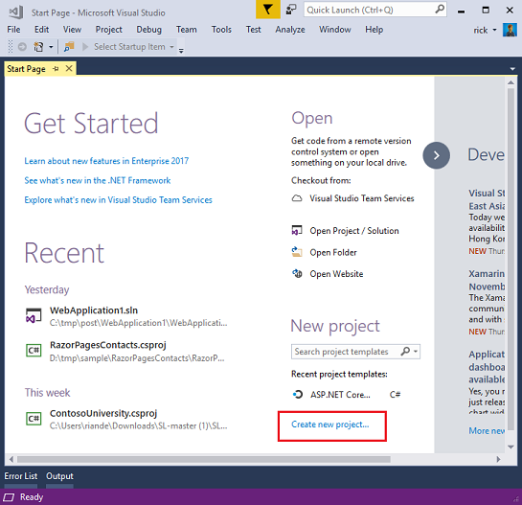

Creating Your First Application

Click **New Project**, then select Visual C# on the left, then **Web** and then select **ASP.NET Web Application (.NET Framework)**. Name your project "MvcMovie" and then click **OK**.

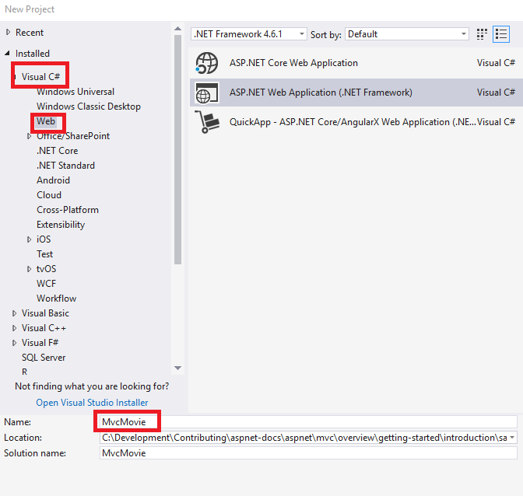

In the **New ASP.NET Project** dialog, click **MVC** and then click **OK**.

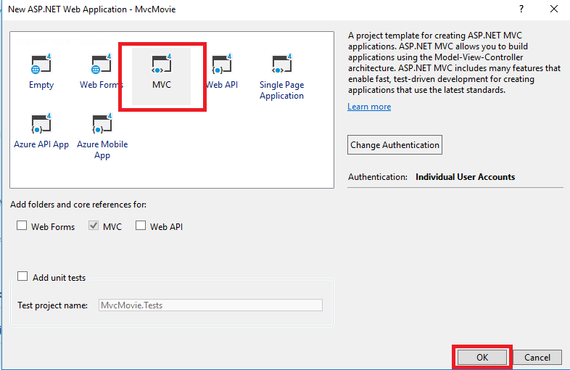

Visual Studio used a default template for the ASP.NET MVC project you just created, so you have a working application right now without doing anything! This is a simple "Hello World!" project, and it's a good place to start your application.

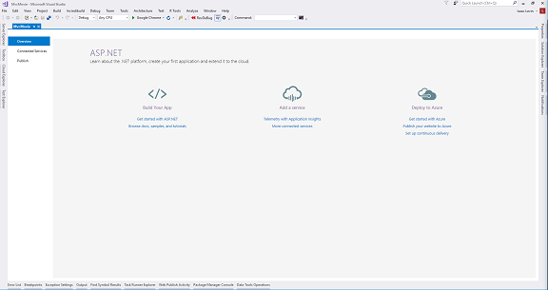

Click F5 to start debugging. F5 causes Visual Studio to start [IIS Express](https://www.iis.net/learn/extensions/introduction-to-iis-express/iis-express-overview) and run your web app. Visual Studio then launches a browser and opens the application's home page. Notice that the address bar of the browser says localhost:port# and not something like example.com. That's because localhost always points to your own local computer, which in this case is running the application you just built. When Visual Studio runs a web project, a random port is used for the web server. In the image below, the port number is 1234. When you run the application, you'll see a different port number.

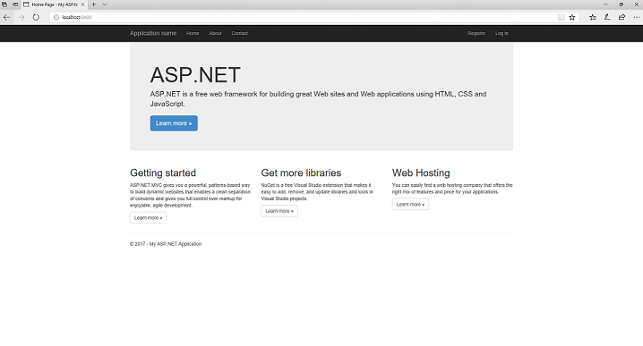

Right out of the box this default template gives you Home, Contact and About pages. The image above doesn't show the **Home**, **About** and **Contact** links. Depending on the size of your browser window, you might need to click the navigation icon to see these links.

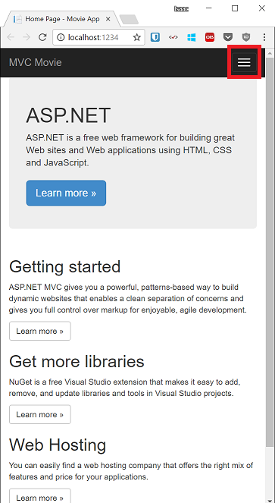1

The application also provides support to register and log in. The next step is to change how this application works and learn a little bit about ASP.NET MVC. Close the ASP.NET MVC application and let's change some code.

For a list of current tutorials, see [MVC recommended articles](https://docs.microsoft.com/en-us/aspnet/mvc/overview/getting-started/mvc-learning-sequence).

See this App Running on Azure

Would you like to see the finished site running as a live web app? You can deploy a complete version of the app to your Azure account by simply clicking the following button.

[https://azuredeploy.net/deploybutton.png](https://azuredeploy.net/?repository=https://github.com/aspnet/Docs/tree/master/aspnet/mvc/overview/getting-started/introduction/sample/MvcMovie&WT.mc_id=deploy_azure_aspnet)

You need an Azure account to deploy this solution to Azure. If you do not already have an account, you have the following options:

* [Open an Azure account for free](https://azure.microsoft.com/en-us/pricing/free-trial/?WT.mc_id=A443DD604) - You get credits you can use to try out paid Azure services, and even after they're used up you can keep the account and use free Azure services.
* [Activate MSDN subscriber benefits](https://azure.microsoft.com/en-us/pricing/member-offers/msdn-benefits-details/?WT.mc_id=A443DD604) - Your MSDN subscription gives you credits every month that you can use for paid Azure services.